Getting set up for CSC160

### CSC160, Prof. Phil Lombardo

(*A special thanks to Dr. Hank Feild for designing and writing this assignment. It has been gently adapted from his original work to suit the needs of our class*)

The purpose of this activity is to get you set up with the tools you'll need to do the work required for this class and connect with the class online.

Prerequisites:

* you have a laptop running Windows, macOS, or Linux (*not* a Chromebook or tablet)
* you know how to take a screenshot for your operating systems
  + macOS: see the "How to capture a portion of your screen" in [this article](https://support.apple.com/en-us/HT201361), or use (command + shift + 4)
  + Windows: use the Snipping Tool (Windows key + shift + s) ([see details here](https://support.microsoft.com/en-us/windows/use-snipping-tool-to-capture-screenshots-00246869-1843-655f-f220-97299b865f6b))

# Outcomes

By the end of this, you should have:

* turned on notifications for Announcements in Canvas
* the Python 3.15 (or higher) interpreter installed
* Visual Studio Code installed
  + the Python plugin installed

# Grading

The following rubric will be used to grade your work on this lab.

|  |  |  |
| --- | --- | --- |
|  | **Yes** | **No** |
| You worked diligently during the lab period and worked well with your partner.  You followed all of the steps, provided all of the requested screenshots, and the screenshots demonstrate that you successfully completed each step. | 5 pts | 0 pts |

# Instructions

1. Setting Course Notifications

If I need to communicate information with you outside of class (e.g., that a class is canceled, that office hours have moved, if an assignment is posted, etc.), I will do it through a Canvas Announcement. In this step, you'll sign up for notifications about Canvas Announcements.

Do this by going to your Canvas account (click your picture on the left hand side of any Canvas page):

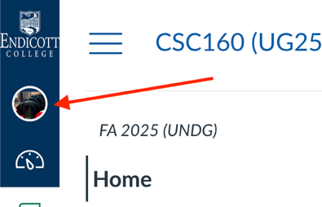

Next, click on "Notifications":

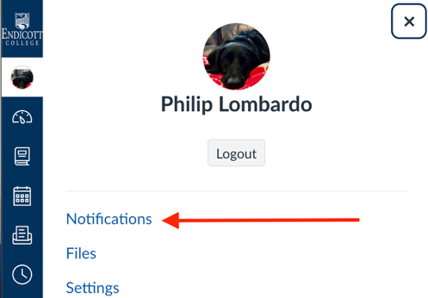

From the "Settings for" dropdown (1 in the screenshot below), select "Account" if you want to change settings for all courses, or select CSC160 if you want to only adjust the settings for this course. Then turn on either or both of the email and push notifications for "Announcements" (2 and 3 in the screenshot):

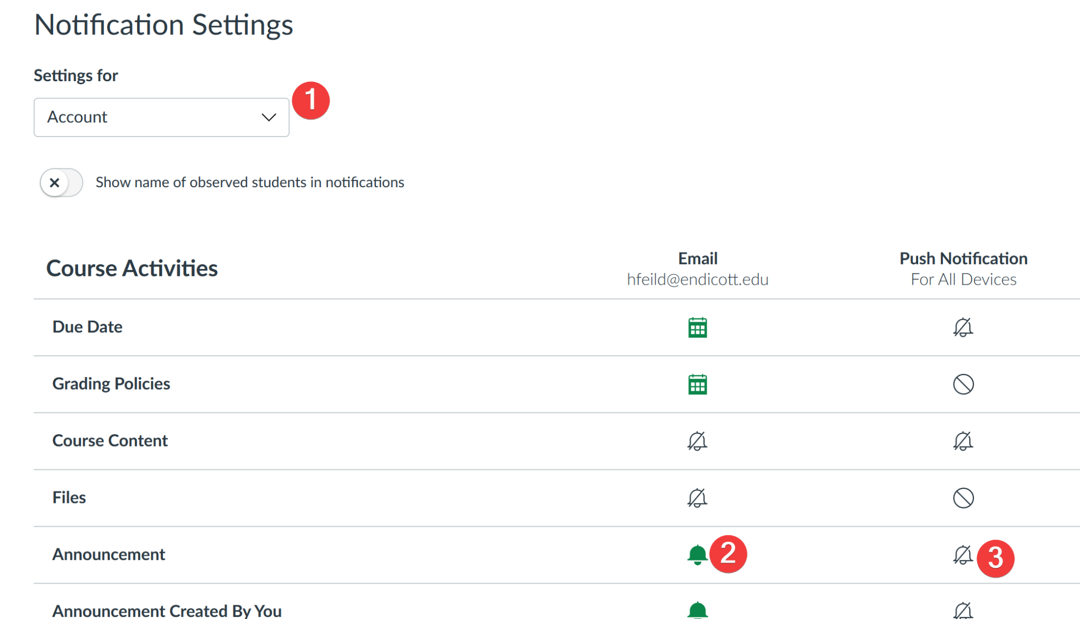

Make sure you select "Notify immediately":

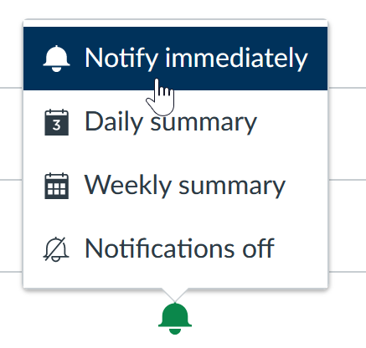

You don't need to screenshot anything for this question.

2. Install a Python interpreter.

**Windows 10/11:** you can install Python 3.13 (or higher) from the Microsoft Store; if asked, click the box to update the system path or environment variables

**macOS/Linux:** go to <https://www.python.org/downloads/> and click the yellow "Download Python 3.x.x" button at the top (the latest version is fine, whatever that happens to be)

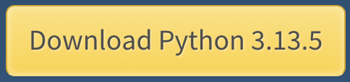

Follow the installation instructions.

To test that your installation works, open up the **PowerShell** (on Windows) or **Terminal** (on macOS) app—these are command line interfaces, which we'll learn about more in a bit. Enter the command:

python3

You should see something that looks like this:

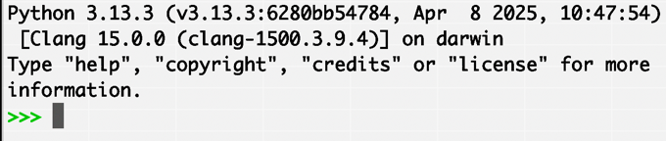

Take a screenshot of your PowerShell or Terminal after running that command and paste it in the purple box below:

|  |
| --- |
|  |

You can close out of PowerShell/Terminal after you've taken the screenshot.

3. Install Visual Studio Code

Go to <https://code.visualstudio.com/download> and select the download for your operating system. Following the installation instructions.

When the installation is complete...

1. open Visual Studio Code up
2. open the integrated terminal by going to "View"->"Terminal" (it may be in a different menu than "View" for you, so look around if you don't see it immediately); this will open a command line interface at the bottom of the Visual Studio Code window
3. click anywhere in the terminal window at the bottom and enter the command: python3

Here is a visual of the steps:

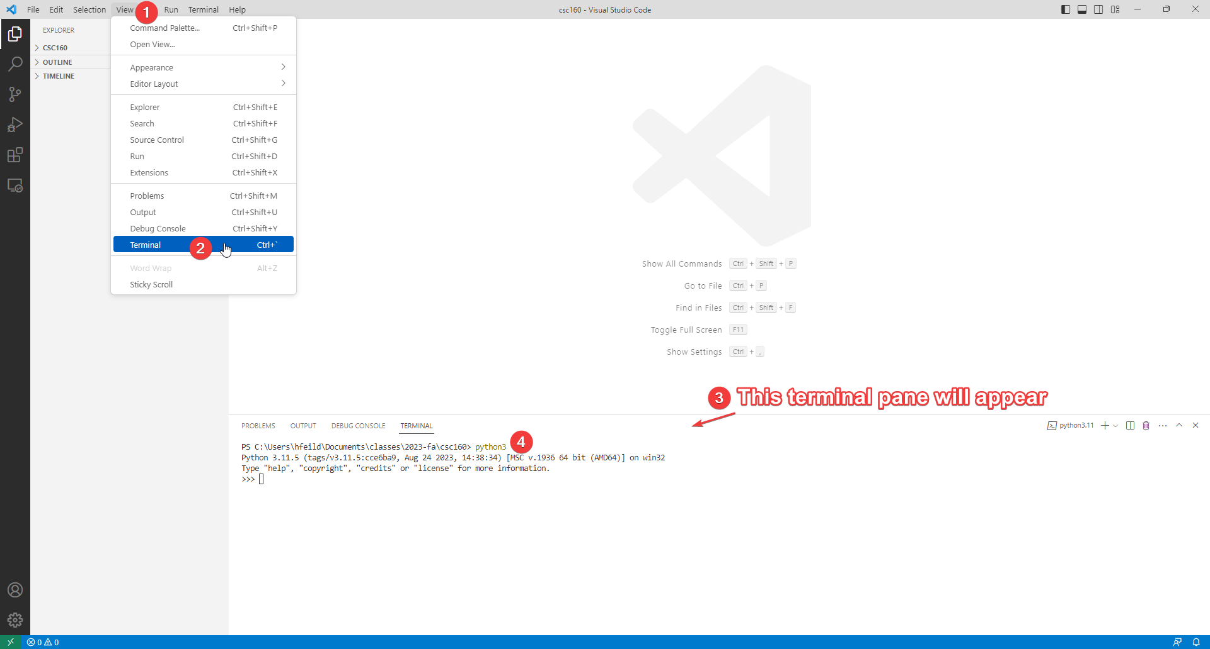

You should see a message similar to what you saw in the previous question when you entered python3 in PowerShell/Terminal.

Take a screenshot of your Visual Studio Code window with the terminal open after running the command above and paste it in the purple box below:

|  |
| --- |
|  |

4. Install the Python extension for Visual Studio Code by (1) clicking the extensions tab from the left sidebar of VS Code, then (2) typing "python" into the search box, and finally (3) clicking "Install".

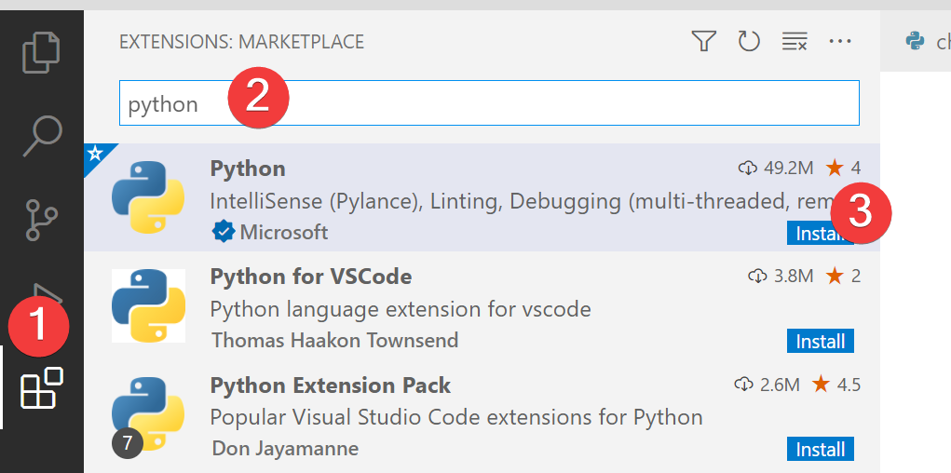

After it installs, clear "python" from the search box, which should cause a list of installed extensions to be displayed. Take a screenshot of that list showing that the Python extension has been installed and paste it in the purple box below.

|  |
| --- |
|  |

When you are finished, call me over so I can confirm you have everything installed. Don't forget to submit a **PDF** version of this to Canvas once you've completed the rest of the lab.

To save as a PDF:

* MAC: go to File --> Save As and look for a place to change the file format to PDF (usually under “export formats”).
* [WINDOWS](https://support.microsoft.com/en-us/office/export-word-document-as-pdf-4e89b30d-9d7d-4866-af77-3af5536b974c): go to File --> Export and look for the PDF option.